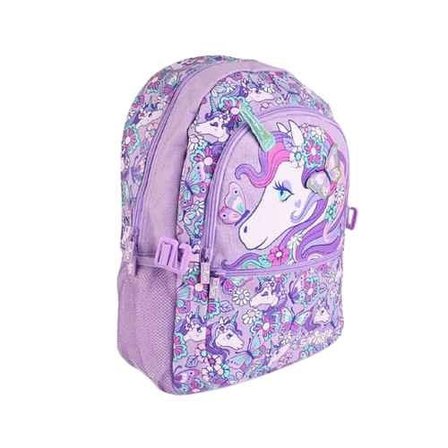

**Product details**

**Pony Backpack**

**Price: $34.99**

**Adventure Awaits, Carry It in Style!**

**The Pony Backpack is designed for young adventurers who love style and comfort. With its spacious compartments and fun, playful design, it’s perfect for school, trips, or daily use. Made from durable materials, this backpack offers both practicality and a touch of whimsy for kids who love to express themselves.**

**.**

.

**THANK YOU!**

**WELLCOME TO OUR WEBSITE**